CHAPTER 4: MUTUAL FUNDS AND
OTHER INVESTMENT COMPANIES

PROBLEM SETS

1. The unit investment trust should have lower operating expenses. Because the investment trust portfolio is fixed once the trust is established, it does not have to pay portfolio managers to constantly monitor and rebalance the portfolio as perceived needs or opportunities change. Because the portfolio is fixed, the unit investment trust also incurs virtually no trading costs.

2. a. Unit investment trusts: Diversification from large-scale investing, lower transaction costs associated with large-scale trading, low management fees, predictable portfolio composition, guaranteed low portfolio turnover rate.

b. Open-end mutual funds: Diversification from large-scale investing, lower transaction costs associated with large-scale trading, professional management that may be able to take advantage of buy or sell opportunities as they arise, record keeping.

c. Individual stocks and bonds: No management fee; ability to coordinate realization of capital gains or losses with investors’ personal tax situations; capability of designing portfolio to investor’s specific risk and return profile.

3. Open-end funds are obligated to redeem investor's shares at net asset value and thus must keep cash or cash-equivalent securities on hand in order to meet potential redemptions. Closed-end funds do not need the cash reserves because there are no redemptions for closed-end funds. Investors in closed-end funds sell their shares when they wish to cash out.

4. Balanced funds keep relatively stable proportions of funds invested in each asset class. They are meant as convenient instruments to provide participation in a range of asset classes. Life-cycle funds are balanced funds whose asset mix generally depends on the age of the investor. Aggressive life-cycle funds, with larger investments in equities, are marketed to younger investors, while conservative life-cycle funds, with larger investments in fixed-income securities, are designed for older investors. Asset allocation funds, in contrast, may vary the proportions invested in each asset class by large amounts as predictions of relative performance across classes vary. Asset allocation funds therefore engage in more aggressive market timing.

5. Unlike an open-end fund, in which underlying shares are redeemed when the fund is redeemed, a closed-end fund trades as a security in the market. Thus, their prices may differ from the NAV.

6. Advantages of an ETF over a mutual fund:
- ETFs are continuously traded and can be sold or purchased on margin.
- There are no capital gains tax triggers when an ETF is sold (shares are just sold from one investor to another).
- Investors buy from brokers, thus eliminating the cost of direct marketing to individual small investors. This implies lower management fees.
Disadvantages of an ETF over a mutual fund:
- Prices can depart from NAV (unlike an open-end fund).
- There is a broker fee when buying and selling (unlike a no-load fund).

7. The offering price includes a 6% front-end load, or sales commission, meaning that every dollar paid results in only $0.94 going toward purchase of shares. Therefore:
Offering price =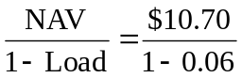= $11.38

8. NAV = Offering price × (1 –Load) = $12.30 × .95 = $11.69

9. Stock Value Held by Fund
A $ 7,000,000
B 12,000,000
C 8,000,000
D 15,000,000
Total $42,000,000
Net asset value = 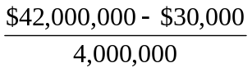= $10.49

10. Value of stocks sold and replaced = $15,000,000
Turnover rate = 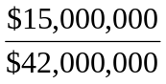= 0.357, or 35.7%

11. a. 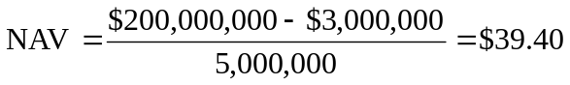

b. Premium (or discount) = 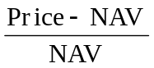 = 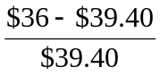= –0.086, or -8.6%
The fund sells at an 8.6% discount from NAV.

12.

13. a. Start-of-year price: P₀ = $12.00 × 1.02 = $12.24
End-of-year price: P₁ = $12.10 × 0.93 = $11.25
Although NAV increased by $0.10, the price of the fund decreased by $0.99.
Rate of return = 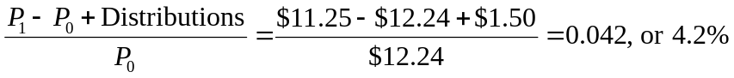

b. An investor holding the same securities as the fund manager would have earned a rate of return based on the increase in the NAV of the portfolio:

14. a. Empirical research indicates that past performance of mutual funds is not highly predictive of future performance, especially for better-performing funds. While there may be some tendency for the fund to be an above average performer next year, it is unlikely to once again be a top 10% performer.

b. On the other hand, the evidence is more suggestive of a tendency for poor performance to persist. This tendency is probably related to fund costs and turnover rates. Thus if the fund is among the poorest performers, investors should be concerned that the poor performance will persist.

15. NAV₀ = $200,000,000/10,000,000 = $20
Dividends per share = $2,000,000/10,000,000 = $0.20
NAV₁ is based on the 8% price gain, less the 1% 12b-1 fee:
NAV₁ = $20 × 1.08 × (1 – 0.01) = $21.384
Rate of return = 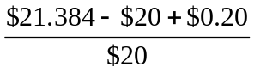= 0.0792, or 7.92%

16. The excess of purchases over sales must be due to new inflows into the fund. Therefore, $400 million of stock previously held by the fund was replaced by new holdings. So turnover is: $400/$2,200 = 0.182, or 18.2%.

- Fees paid to investment managers were: 0.007 × $2.2 billion = $15.4 million
Since the total expense ratio was 1.1% and the management fee was 0.7%, we conclude that 0.4% must be for other expenses. Therefore, other administrative expenses were: 0.004 × $2.2 billion = $8.8 million.

- As an initial approximation, your return equals the return on the shares minus the total of the expense ratio and purchase costs: 12% − 1.2% − 4% = 6.8%.

But the precise return is less than this because the 4% load is paid up front, not at the end of the year.
To purchase the shares, you would have had to invest: $20,000/(1 − 0.04) = $20,833.
The shares increase in value from $20,000 to: $20,000 × (1.12 − 0.012) = $22,160.
The rate of return is: ($22,160 − $20,833)/$20,833 = 6.37%.

Assume $1,000 investment | Loaded-Up Fund | Economy Fund
Yearly growth (r is 6%) | 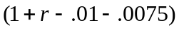 | 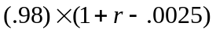
t = 1 year | $1,042.50 | $1,036.35
t = 3 years | $1,133.00 | $1,158.96
t = 10 years | $1,516.21 | $1,714.08

- a. 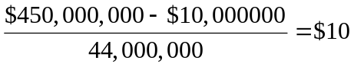
b. The redemption of 1 million shares will most likely trigger capital gains taxes which will lower the remaining portfolio by an amount greater than $10,000,000 (implying a remaining total value less than $440,000,000). The outstanding shares fall to 43 million and the NAV drops to below $10.

21. Suppose you have $1,000 to invest. The initial investment in Class A shares is $940 net of the front-end load. After four years, your portfolio will be worth:
$940 × (1.10)⁴ = $1,376.25
Class B shares allow you to invest the full $1,000, but your investment performance net of 12b-1 fees will be only 9.5%, and you will pay a 1% back-end load fee if you sell after four years. Your portfolio value after four years will be:
$1,000 × (1.095)⁴ = $1,437.66
After paying the back-end load fee, your portfolio value will be:
$1,437.66 × .99 = $1,423.28
Class B shares are the better choice if your horizon is four years.
With a 15-year horizon, the Class A shares will be worth:
$940 × (1.10)¹⁵ = $3,926.61
For the Class B shares, there is no back-end load in this case since the horizon is greater than five years. Therefore, the value of the Class B shares will be:
$1,000 × (1.095)¹⁵ = $3,901.32
At this longer horizon, Class B shares are no longer the better choice. The effect of Class B's 0.5% 12b-1 fees accumulates over time and finally overwhelms the 6% load charged to Class A investors.

22. a. After two years, each dollar invested in a fund with a 4% load and a portfolio return equal to r will grow to: $0.96 × (1 + r – 0.005)².
Each dollar invested in the bank CD will grow to: $1 × 1.06².
If the mutual fund is to be the better investment, then the portfolio return (r) must satisfy:
0.96 × (1 + r – 0.005)² > 1.06²
0.96 × (1 + r – 0.005)² > 1.1236
(1 + r – 0.005)² > 1.1704
1 + r – 0.005 > 1.0819
1 + r > 1.0869
Therefore: r > 0.0869 = 8.69%

b. If you invest for six years, then the portfolio return must satisfy:
0.96 × (1 + r – 0.005)⁶ > 1.06⁶ = 1.4185
(1 + r – 0.005)⁶ > 1.4776
1 + r – 0.005 > 1.0672
r > 7.22%
The cutoff rate of return is lower for the six-year investment because the “fixed cost” (the one-time front-end load) is spread over a greater number of years.

c. With a 12b-1 fee instead of a front-end load, the portfolio must earn a rate of return (r) that satisfies:
1 + r – 0.005 – 0.0075 > 1.06
In this case, r must exceed 7.25% regardless of the investment horizon.

23. The turnover rate is 50%. This means that, on average, 50% of the portfolio is sold and replaced with other securities each year. Trading costs on the sell orders are 0.4% and the buy orders to replace those securities entail another 0.4% in trading costs. Total trading costs will reduce portfolio returns by: 2 × 0.4% × 0.50 = 0.4%

24. For the bond fund, the fraction of portfolio income given up to fees is:
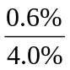= 0.150, or 15.0%
For the equity fund, the fraction of investment earnings given up to fees is:
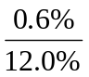= 0.050, or 5.0%
Fees are a much higher fraction of expected earnings for the bond fund and therefore may be a more important factor in selecting the bond fund.
This may help to explain why unmanaged unit investment trusts are concentrated in the fixed income market. The advantages of unit investment trusts are low turnover, low trading costs, and low management fees. This is a more important concern to bond-market investors.

25. Suppose that finishing in the top half of all portfolio managers is purely luck, and that the probability of doing so in any year is exactly ½. Then the probability that any particular manager would finish in the top half of the sample five years in a row is (½)⁵ = 1/32. We would then expect to find that [350 × (1/32)] = 11 managers finish in the top half for each of the five consecutive years. This is precisely what we found. Thus, we should not conclude that the consistent performance after five years is proof of skill. We would expect to find 11 managers exhibiting precisely this level of "consistency" even if performance is due solely to luck.

